1.Recurrent Neural Network (RNN)

What is RNN?
A Recurrent Neural Network (RNN) is a type of neural network designed for processing sequential data. Unlike traditional neural networks, RNNs have a memory mechanism that allows them to remember previous information and use it while processing the current input.

RNN Architecture Diagram:
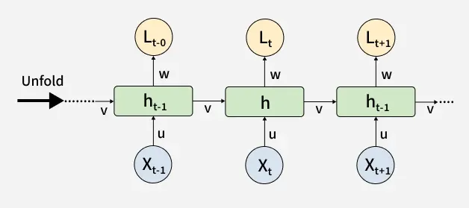

Diagram Explanation:
An RNN consists of three main components:
- Input Layer:
· Receives input data at each time step.
· Example: A word in a sentence.
- Hidden Layer:
· Stores information from previous time steps.
· The hidden state acts as the memory of the network.
- Output Layer:
· Produces the final prediction.

Limitations of RNN:
Although RNNs are useful for sequential data, they have some problems:

1.Vanishing Gradient Problem:
When training long sequences, gradients become very small. Because of this, the network cannot learn information from earlier steps.

2.Short-Term Memory:

RNNs can remember recent information but struggle to remember information from long sequences.

Example:
"The book that I bought yesterday from the store was very interesting."
An RNN may forget the relationship between "book" and "interesting".

3.Slow Training:
RNN processes data step-by-step, making training slower compared to other neural networks.

2.Long Short-Term Memory (LSTM):
What is LSTM?
Long Short-Term Memory (LSTM) is an advanced version of RNN designed to solve the problems of short-term memory and vanishing gradients.

LSTM uses a special memory system called a cell state and uses gates to control information flow.
LSTM Architecture Diagram:
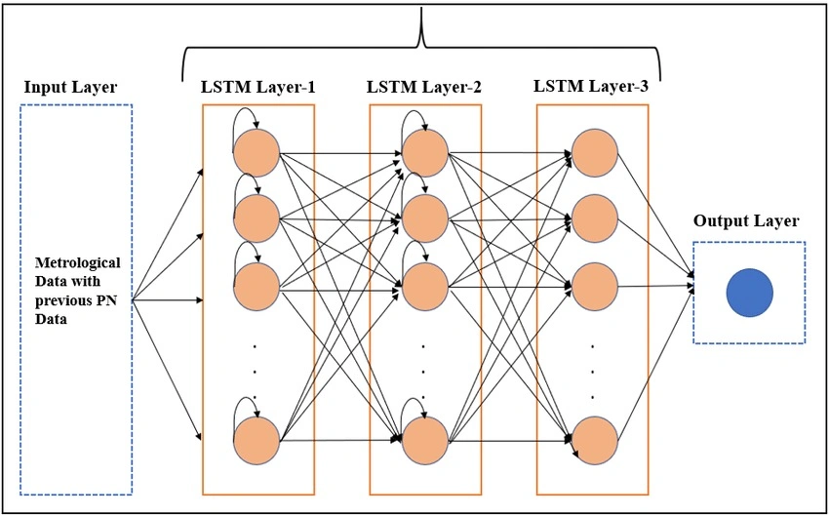
An LSTM unit contains three main gates:

1. Forget Gate:
The forget gate decides which information from previous memory should be removed.
Example:
If old information is not useful, the forget gate deletes it.
Formula:
fₜ = σ(Wf[hₜ₋₁, Xₜ] + bf)

2. Input Gate:
The input gate decides which new information should be stored in memory.
It updates the cell state with important new information.

3. Output Gate:
The output gate controls which information from the cell state should be used as output.

Limitations of LSTM:
Although LSTM performs better than RNN, it still has some limitations:

1. Complex Architecture:
LSTM contains multiple gates, making it more complicated than RNN.

2. More Parameters:
Because of more calculations and parameters, LSTM requires more memory and training time.

3. Slower Training:
The large architecture makes training slower compared to simpler models.

3. Gated Recurrent Unit (GRU):

What is GRU?
Gated Recurrent Unit (GRU) is another improved version of RNN introduced to overcome the limitations of traditional RNN.
GRU has a simpler structure than LSTM but provides similar performance in many tasks.
Unlike LSTM, GRU does not use a separate cell state. It combines memory and hidden state into one unit.
GRU Architecture Diagram:
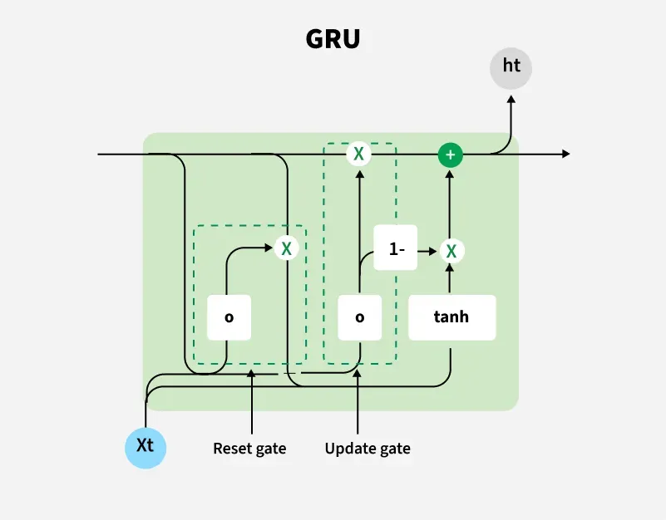

1. Update Gate:
The update gate decides how much previous information should be kept and how much new information should be added.
It works similarly to the combination of forget gate and input gate in LSTM.

Reset Gate:

The reset gate decides how much previous information should be ignored when creating new information.

Limitations of GRU:

1. Less Control Over Memory:
GRU has fewer gates, so it provides less control compared to LSTM.

2. Not Always Better for Long Sequences:
For very long and complex sequences, LSTM may perform better.

3. Limited Research Compared to LSTM:
LSTM has been studied more extensively in many applications.

Comparison Between RNN, LSTM, and GRU:

Feature | RNN | LSTM | GRU
Full Form | Recurrent Neural Network | Long Short-Term Memory | Gated Recurrent Unit
Memory Ability | Low | High | High
Architecture Complexity | Simple | Complex | Medium
Number of Gates | No gates | Three gates (Forget, Input, Output) | Two gates (Update, Reset)
Cell State | Not available | Separate cell state available | No separate cell state
Training Speed | Faster | Slower | Faster than LSTM
Parameters | Less | More | Less than LSTM
Long-Term Dependency | Poor | Excellent | Good
Vanishing Gradient | High | Reduced | Reduced
Computation Cost | Low | High | Medium
Performance | Suitable for simple sequence tasks | Best for complex long sequences | Good balance of speed and accuracy

